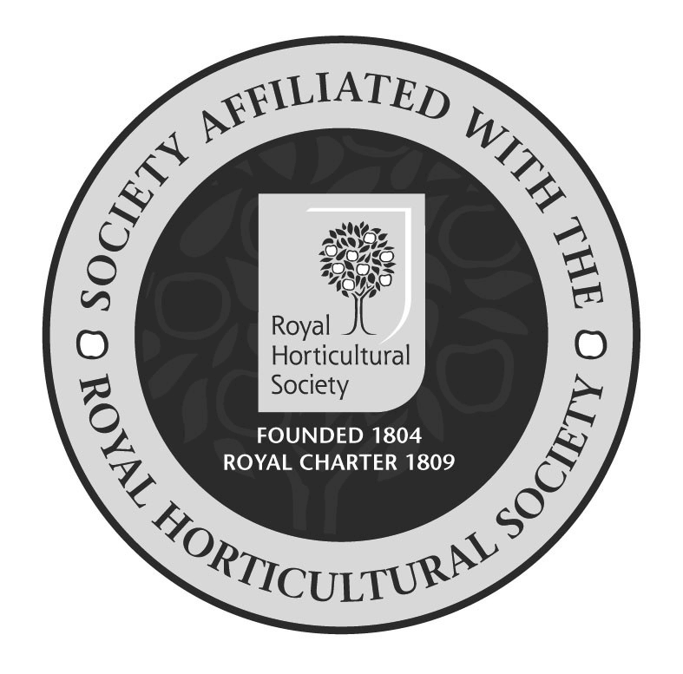
DISLEY & LYME
Horticultural Society

Disley & Lyme Horticultural Society 112th ANNUAL SHOW is being held on Saturday, 17th August 2019 at Disley Amalgamated Sports Club

Show general class listings are now available on www.dlhs.weebly.com with hard copies of show schedules in local outlets and the local libraries now.

A free shuttle bus we be circulating from 11:45 on show day and throughout the afternoon between High Lane Library, the bus stop on the A6, opposite the Rams Head and the Show ground. All are very welcome to use this service.

The show gates will be opening at Noon with the official show welcome by Rev. Stuart Cornes, Vicar of St Mary’s Church, Disley at 12:45 in the marquee.

The remaining timetable is:

Barbeque opens 12.30
Basin Street Jazz & Blues 12:30
Pet Show 14:00
Flower Arranging Demo 14:30
Disley Community Choir 15:00
Prize Money distribution 16:15
Trophy Presentation 16:30
Followed by auction and raffle in the marquee

In addition to the usual Art Society and Disley & District Flower club displays this year there are an amazing SEVEN SPECIALIST DEMONSTRATORS at the show:

East Cheshire Alpine Society

East Cheshire Cactus Society

The Clematis Society

The Cottage Gardens Society

Manchester Bonsai Society

Stockport Bee Keepers

Streptocarpus Society

“Disley Community Choir” and “Basin Street Jazz and Blues were a great success at last years’ show and will both be returning once again and performing on show day!”

Additionally numerous field stalls and children’s attractions will be on the field as well as a BBQ, Ice Creams, WI Cake Stall, WI Afternoon Teas, Amalgamated Bar, DLHS Plant Stall

